**Introduction To .NET Compilation and Common Language Runtime ( CLR )**

 To understand the compilation process of .NET Framework, we first need to see, understand and compare the compilation processes of other frameworks or other programming languages.

**- Compilation of A Source Code In C/C++ Programming Languages**

When we write our code in C/C++ programming languages and when we compile our source code in these programming languages, the source code first gets converted into a .obj file that contains the machine code of our source code. Secondly, the linker links some required/dependent library code in our code so that our source code can be run without any problems. Finally, the .obj file is converted in .exe (software). Remember, the compilers of these languages convert the source code into .obj file in accordance to the operating system and the system architecture and the application developed on this architectures/operating systems with these languages cannot be run on other architectures/operating systems or other platforms, this is the reason why C/C++ and other old languages are platform dependent.

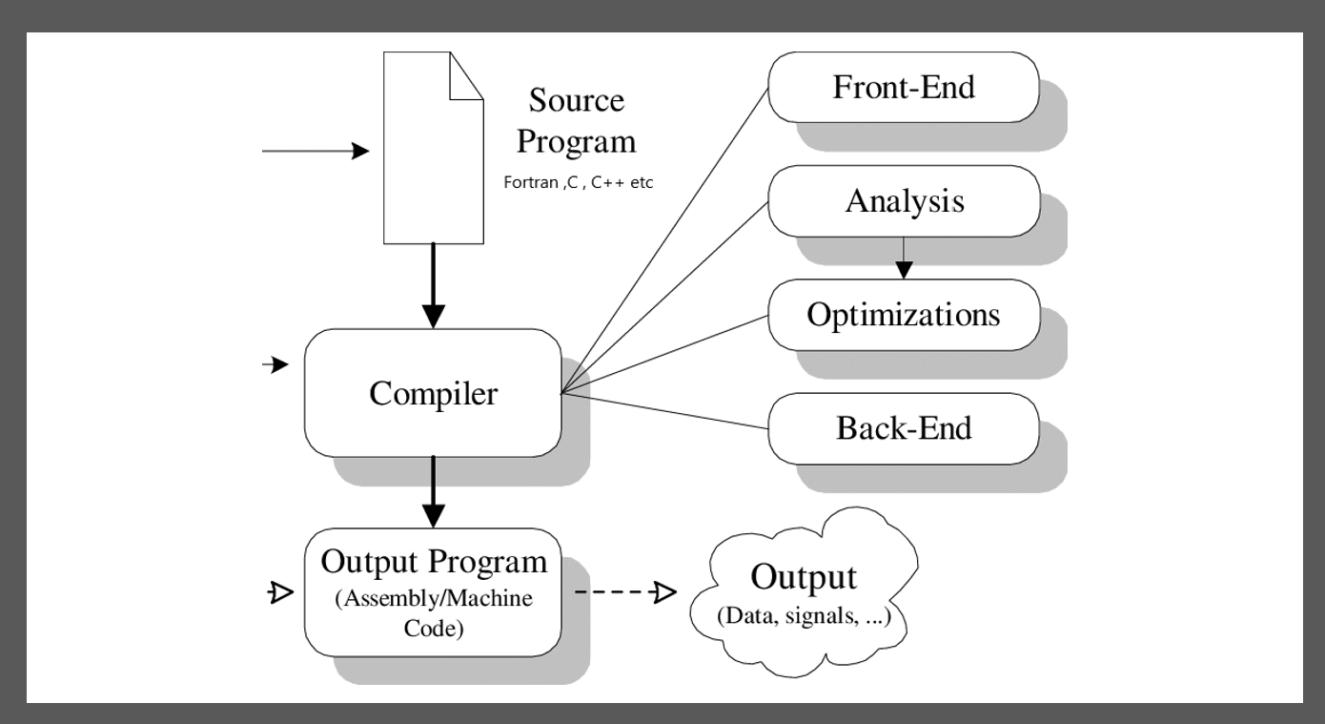

**- Compilation of A Source Code In Java Programming Languages**

 Now when we talk about java's compilation mechanism, we see, java does not directly convert the source code into machine code. It first converts the java source code into a byte code, this byte code can be understood by any operating system. This byte code is later converted into machine code by JVM (Java Virtual Machine). The Java virtual machine is a process virtual machine that reads the operating system and architecture's configuration and convert the byte code into machine language at run time with JIT interpreter according to that operating system / architecture. This allows java's application to run on different platforms like Linux, Windows, MacOS, IOS, Android etc. and makes it a platform independent language.

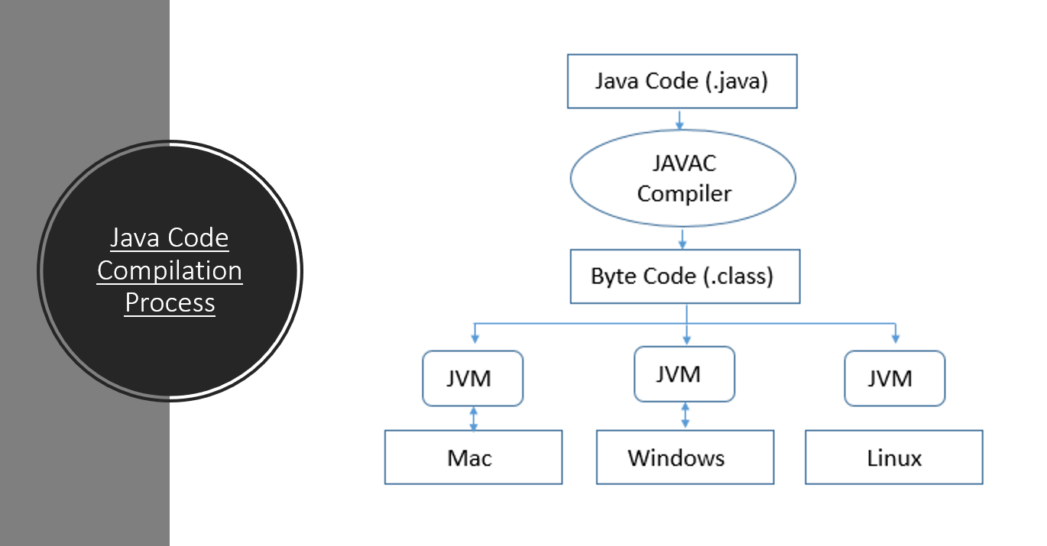

**- Compilation Of A Source Code In Microsoft's .NET Framework Supported Languages**

The .NET Framework supports more than 60 programming languages. The .NET framework allows programmers to make their projects/applications with the use of multiple languages. This is done when .NET languages compilers convert the source code of different languages into a common intermediate language code. This common intermediate code is called MSIL (Microsoft’s Intermediate Language) and it can be generated by 60+ supported languages in Microsoft .NET Framework. After the conversion is done into MSIL We cannot determine from which programming language the resultant MSIL is generated because it is common to all the supported languages in .NET Framework. This MSIL is similar to the Byte Code In Java but it supports more than 60+ languages but java byte code can only be generated by java programming language but in .NET the MSIL can be converted from 60+ .NET supported programming language. Therefore, with .NET Framework we can code with multiple languages in our projects. The CLR later converts this MSIL into machine code with the use of JIT compiler at runtime which makes C# and .NET framework platform independent for all the windows operating systems only. But, Microsoft .NET Core is 100% platform independent to all the operating systems and it allows .NET applications to run on different operating systems also just like Java and it also allows developer to use 60+ .NET supported programming languages.

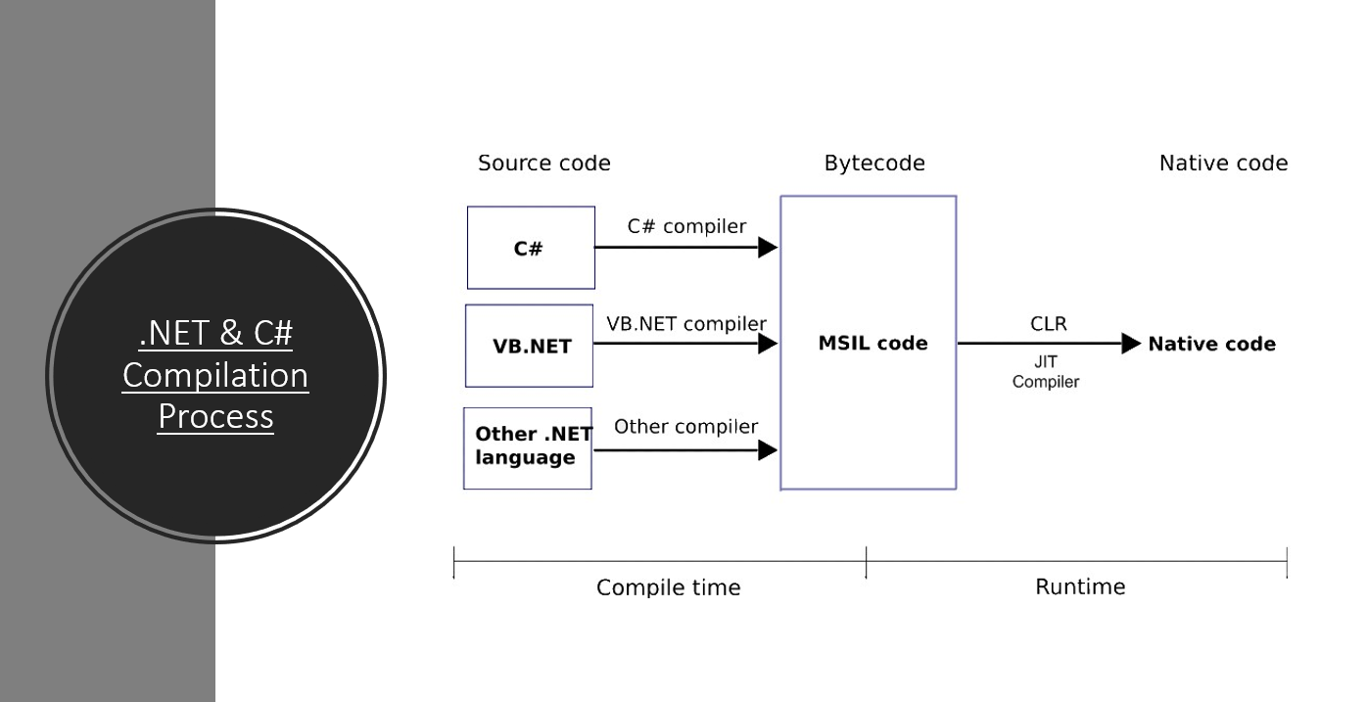

**- The Common Language Runtime ( CLR )**

The Common Language Runtime is the implementation of Common Language Infrastructure. The CLR converts the MSIL code into machine code at runtime using JIT compiler. The JIT compiler is the component of CLR. It has many other components that manage our code, allows us to debug the code, allows type checking in our code and many other facilities are provided by the components of CLR. The components and the complete picture of CLR can be seen below,

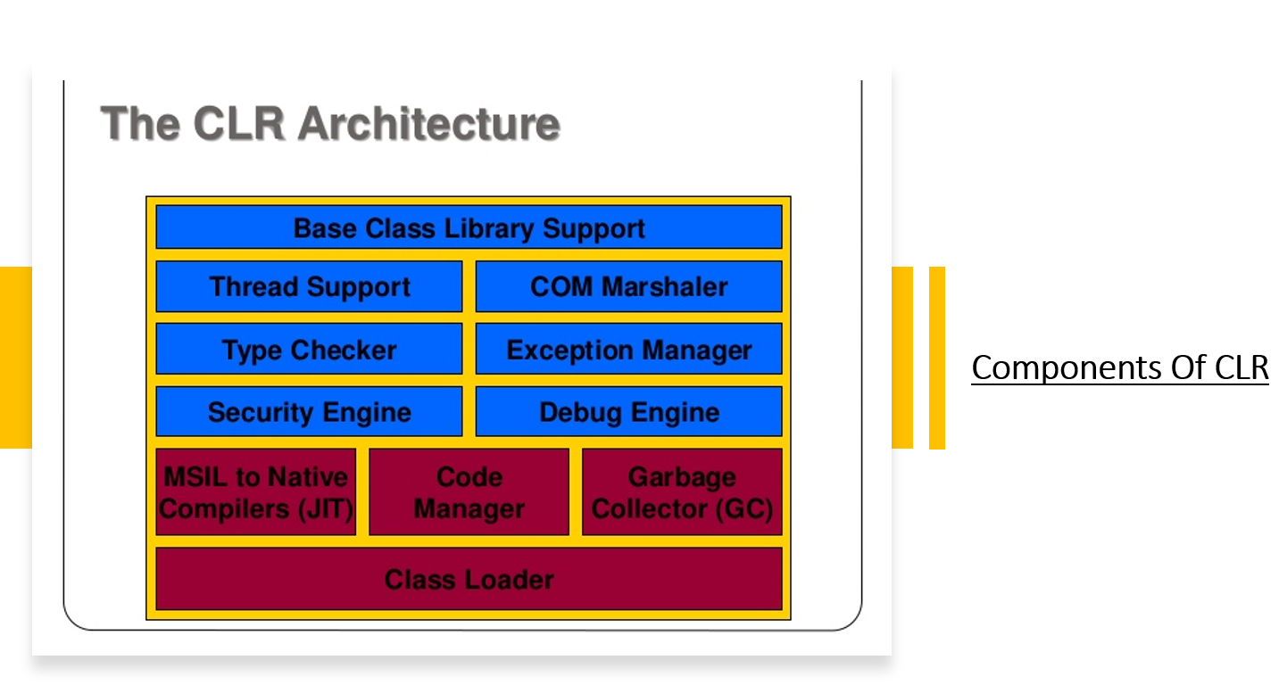

To Understand More About .NET Framework & CLR you can watch my video here on YouTube : https://youtu.be/Pl1lFAmuVVA  
You can also view my GitHub repository that can help you understand .NET framework & C# programming language from the link : <https://github.com/TashikMoin23/Learn-Microsoft-CSharp>

You can also contact me on LinkedIn : <https://www.linkedin.com/in/tashik-moin-sheikh-08872116b/>